Cryptography Midterm Exam I 2007/04/16

Part I (3 points each)
1. Which value of Legendre symbol or Jacoby symbol is correct?
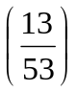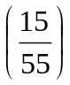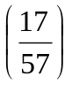
A. = −1 B. = −1 C. = −1
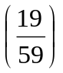
D. = −1 E. None of the above
2. Denote h as a hash function, k as a key, m as a message, p₁ and p₂ as padding strings. Which is the value of HMAC_{k}(m)?
A. h(k || m) B. h(m || k) C. h(k || p || m || k)
D. h(k || p₁ || h(k || p₂ || m)) E. None of the above

- Whose size of the key space is approximately equal to the complexity
of finding a collision of SHA-224?
A. 192-bit AES B. 256-bit AES C. 2-key Triple-DES D. 3-key Triple-DES E. None of the above
4. Which hash function is simply a truncated version of SHA-512, computed with different initial values?
A. SHA-384 B. SHA-256 C. MD5
D. RIPEMD-160 E. None of the above

5. In which operation of AES, each set of four bytes in a state is treated
as a degree-3 polynomial over F₂₅₆?
A. ByteSub B. MixColumn C. AddRoundKey
D. ShiftRow E. None of the above

6. By which mode of operation, a block cipher can be used to construct
a self-synchronizing stream cipher?
A. ECB B. CBC C. OFB D. CFB E. None of the above

7. Which value of Euler φ-function is NOT equal to 40?
  - φ (41) B. φ (75) C. φ (88) D. φ (132) E. None of the above

8. In a Feistel cipher, every encryption round consists of L_{i} = R_{i −1} and
A. R_{i} = L_{i −1} ⊕ f (R_{i −1}, k_{i} ) B. R_{i} = L_{i −1} ⊕ f (L_{i −1}, k_{i} )
C. R_{i} = R_{i −1} ⊕ f (L_{i −1}, k_{i} ) D. R_{i} = R_{i −1} ⊕ f (R_{i −1}, k_{i} )
E. None of the above

9. Which is true about the symmetric group S₅?
A. | S₅ | = 60 B. < (1, 2, 3, 4, 5) > is a normal subgroup
C. ( S₅ : S₄ ) = 10 D. ( S₅ : < (1, 2, 3), (1, 2) > ) = 30
E. None of the above

10. Which statement is FALSE about the eSTREAM project?
A. The goal is to identify new stream ciphers that might become
suitable for widespread adoption
  - Profile 1 contains submissions of stream ciphers for hardware applications with high throughput requirements
  - Profile 2 contains submissions of stream ciphers for hardware applications with restricted resources such as limited storage,
gate count, or power consumption
  - Profile 1A or 2A contains stream ciphers satisfying Profile 1 or 2
with an associated authentication method respectively
E. None of the above

Part II (3 points each)

• Consider the elliptic curve group defined by y² = x³ + x over F₂₃ .
There are 23 points satisfying the equation as the graph below.
Let P = (1, 5) and Q = (9, 18).
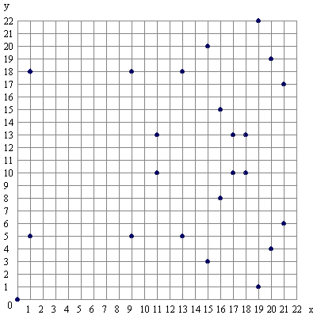
■ The order of the elliptic curve group is 11 .
■ P + Q = 12 .
■ – Q = 13 .
■ 2P = 14 .
■ 4P = 15 .
■ 2007P = 16 .

• Since P ( x ) = x⁵ + 2x + 1 is irreducible over F₃ , the quotient ring
K = F₃ [x] / (P ( x )) is a finite field. Let Q ( x ) = x² + 2x + 1.
■ The number of elements in K is | K | = 17 .
■ Q ( x ) ¹²¹³ = 2x³ + 18 in K.
■ Q ( x ) ⁻¹ = x⁴ + 19 in K.
■ To prove that P ( x ) is primitive, it is sufficient to show x^{m} ≠ 1
and x^{n} ≠ 1 in K where m, n > 0. We have min(m, n) = 20 .

• Consider the integer values of x satisfying
x ≡ 11 (mod 27) and x ≡ 10 (mod 29).
■ The smallest positive solution is x = 21 .
■ The largest negative solution is x = 22 .

• For a set G, we denote (G, +) as an additive group and (G, ×) as
a multiplicative group respectively. Consider the homomorphism
h: (Z, +) → (Z₃₁*, ×) defined by h(x) = 4^{x} mod 31.
■ (Z / Ker(h), +) is isomorphic to (Z_{n}, +) where n = 23 .
■ The index ( (Z₃₁*, ×) : (Im(h), ×) ) = 24 .
■ Apparently 4 is not a generator of the cyclic group (Z₃₁*, ×).
The smallest positive integer generating (Z₃₁*, ×) is 25 .

• Assume the periodic sequence 1, 0, 1, 1, 1, 0, 0, 1, 0, 1, 1, 1, 0, 0, …
of period 7 is generated by an LFSR (Linear Feedback Shift Register).
■ If the connection polynomial is primitive, it is 26 .
■ The linear complexity of the sequence is 27 .

• Determine the period of the sequence generated by LFSR of register length 8 with non-zero initial state and connection polynomial C(x).
■ C(x) = x⁸ + x⁵ + x³ + x² + 1 (primitive), then the period is 28 .
■ C(x) = x⁸ + x⁵ + x⁴ + x³ + 1 (irreducible but not primitive), then
the period is 29 . (Hint: Less than 30)
■ C(x) = x⁸ + x⁵ + x³ + 1 (reducible), then the maximal possible
period is 30 .

Part III (Write down all details of your work)

31 (2 points)
Sketch the flow chart of CBC-MAC.

32 (3 points)
Sketch the flow chart of OFB mode (Output Feedback), including both encryption and decryption.

• A cryptographic hash function should satisfy these three assumptions:
(A) Pre-image Resistant
− Given y, hard to find x such that h(x) = y
(B) Collision Resistant
− Hard to find any x ≠ x′ such that h(x) = h(x′)
(C) Second Pre-image Resistant
− Given h(x), hard to find x′ (≠ x) with h(x) = h(x′)
Denote “M > N” as “M is a stronger assumption than N”.
33 (2 points)
Order the strength of the assumptions (A), (B), and (C).
That is, answer in the form of “L > M > N”.
34 (3 points)
Prove your claim of the relation between (A) and (B).

Cryptography Midterm Exam I 2007/04/16
Name: ____________ Student ID number: ____________

1 | 2 | 3 | 4 | 5 | 6 | 7 | 8 | 9 | 10
11 |  | 12 |  | 13 |  | 14 |  | 15
16 |  | 17 |  | 18 |  | 19 |  | 20
21 |  | 22 |  | 23 |  | 24 |  | 25
26 |  | 27 |  | 28 |  | 29 |  | 30

31 32 33 34
Cryptography Midterm Exam I 2007/04/16
Solution
1 | 2 | 3 | 4 | 5 | 6 | 7 | 8 | 9 | 10
C | D | C | A | B | D | E | A | E | B
11 |  | 12 |  | 13 |  | 14 |  | 15
24 |  | (16, 8) |  | (9, 5) |  | (0, 0) |  | O (Infinity)
16 |  | 17 |  | 18 |  | 19 |  | 20
(1,18) |  | 243 (3⁵) |  | x² + 2x + 1 |  | x³ + 2x + 1 |  | 22
21 |  | 22 |  | 23 |  | 24 |  | 25
416 |  | -367 |  | 5 |  | 6 |  | 3
26 |  | 27 |  | 28 |  | 29 |  | 30
x³ + x² + 1 |  | 3 |  | 255 |  | 17 |  | 30

1 1,0,-1,1 3 ≈2¹¹² 9 120,[(12)(12345)(12)∉<(12345)>],5,20 10 Profile I for software applications 16 2007P = –P since 4P = O 18 Q^{242×5+3}=Q³, note (a+b)^{p}=a^{p}+b^{p} over F_{p}
19 Extended Euclidean (GCD) algorithm: P(x) = (x³+x²+2)Q(x)+(x+2), Q(x) = x(x+2)+1, so 1 = Q(x)−x(x+2) = Q(x)–x[P(x)−(x³+x²+2)Q(x)] = −xP(x)+ Q(x)(x⁴+x³+2x+1)
20 min(242/2, 242/11) 24 Im(h)={1,2,4,8,16} 27 Shortest length of generating LFSR
28 2⁸−1 29 17|255 and C(x)|(x¹⁷+1)
33 B>C>A 34 Similar but not identical to the proof of Lemma 9.1
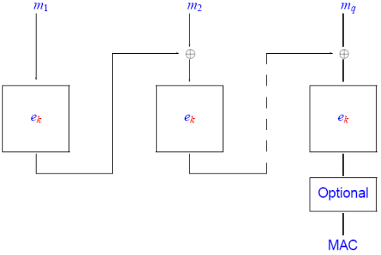
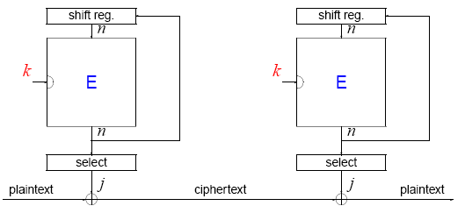
31 32

